**ASSIGNMENT 2**

**DATA VISUALIZATION AND PRE-PROCESSING**

|  |  |
| --- | --- |
| Assignment Date | 24 September 2022 |
| Student Name | Sowndarya S |
| Student Roll Number | 2019105580 |
| Maximum Marks | 2 Marks |

1)The dataset is downloaded.

2)The file dataset is loaded.

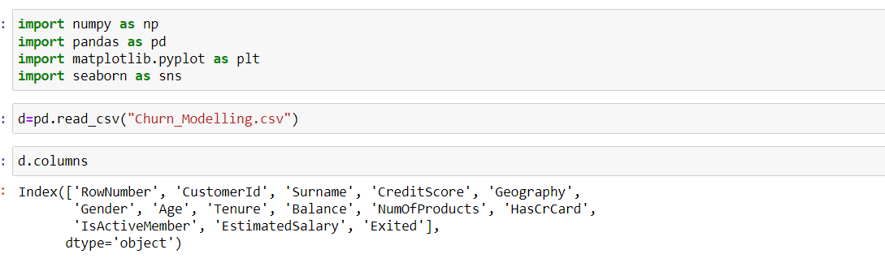

3)Performing Visualization:

**a) Univariate Analysis:**

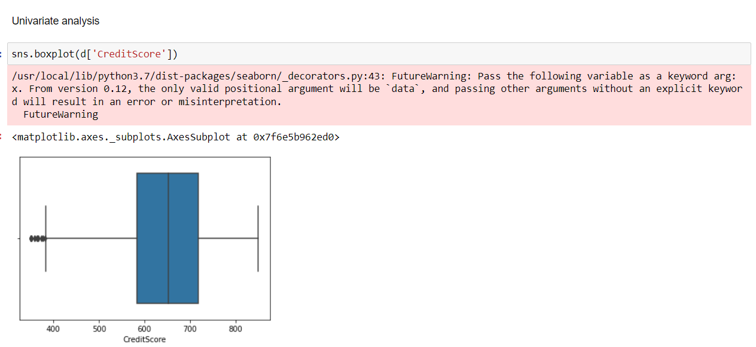

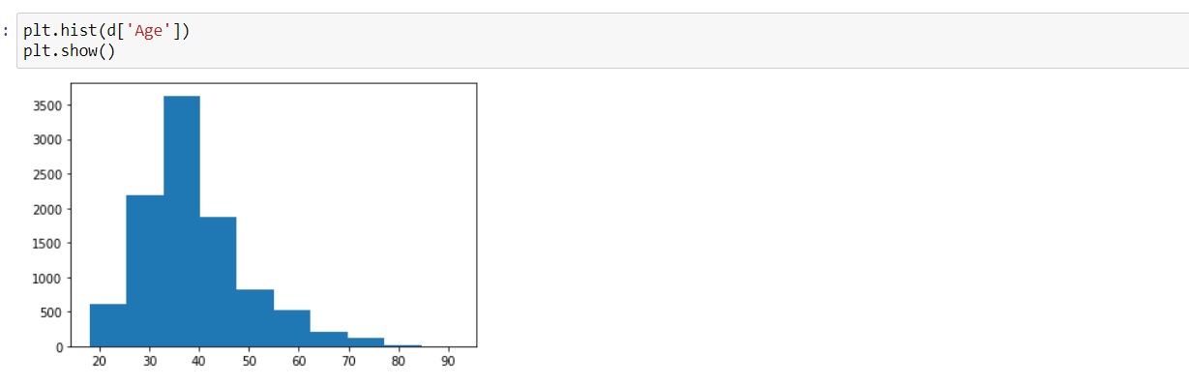

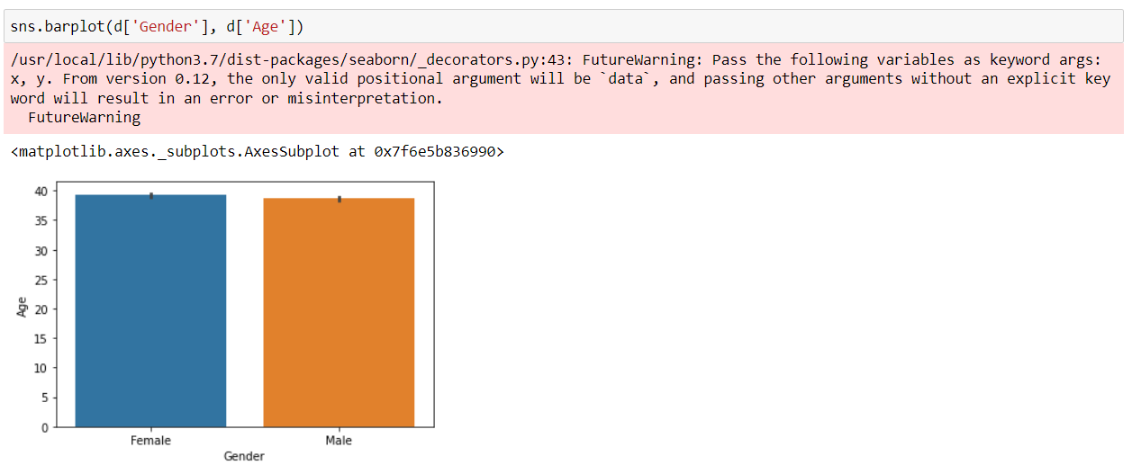

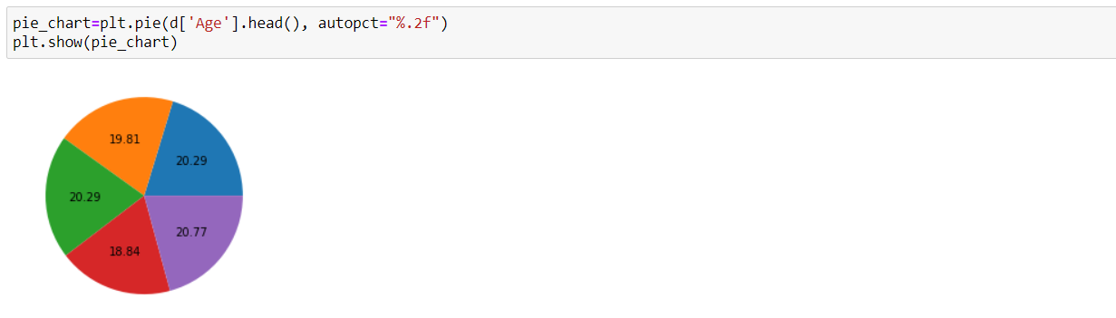

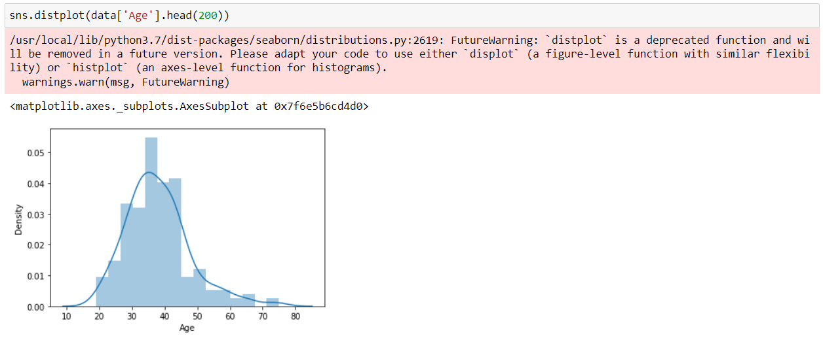

**b) Bi-variate Analysis:**

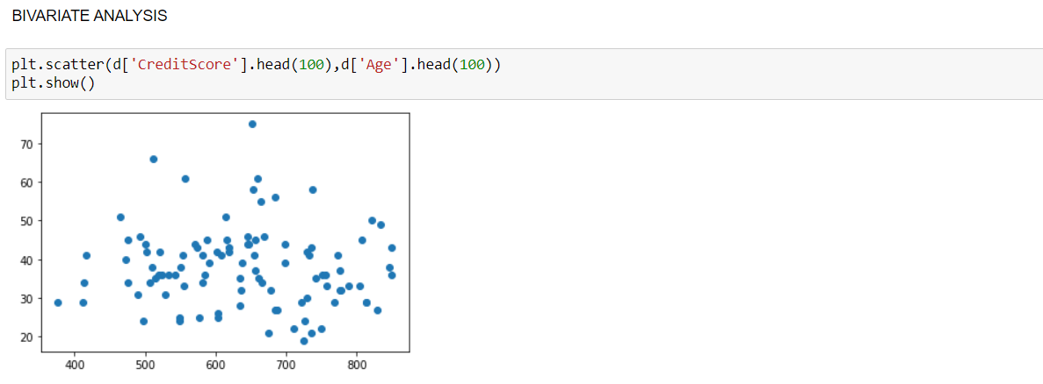

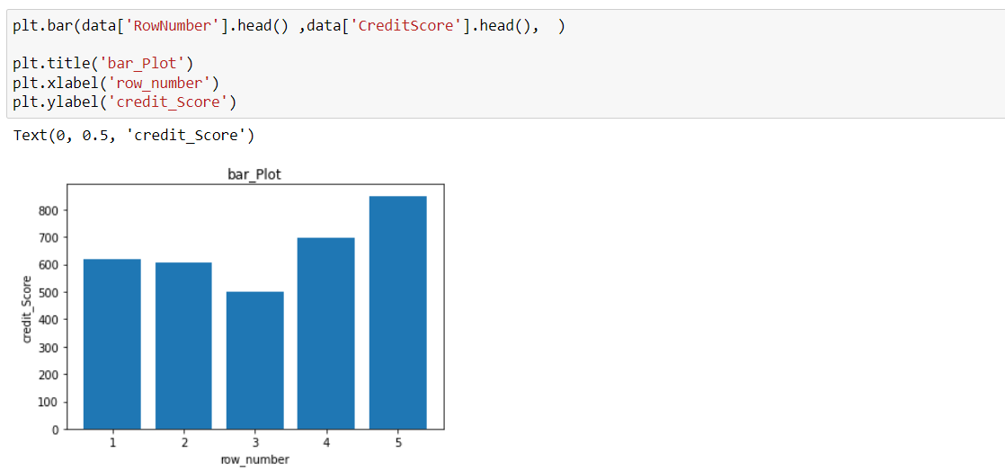

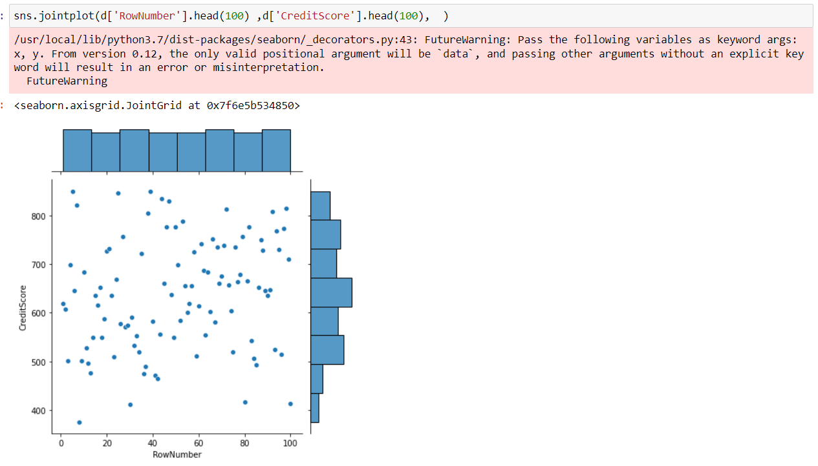

**c) Multi-variate Analysis:**

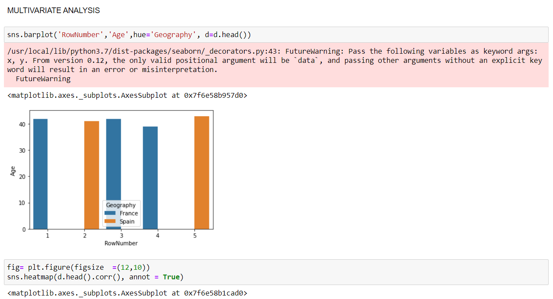

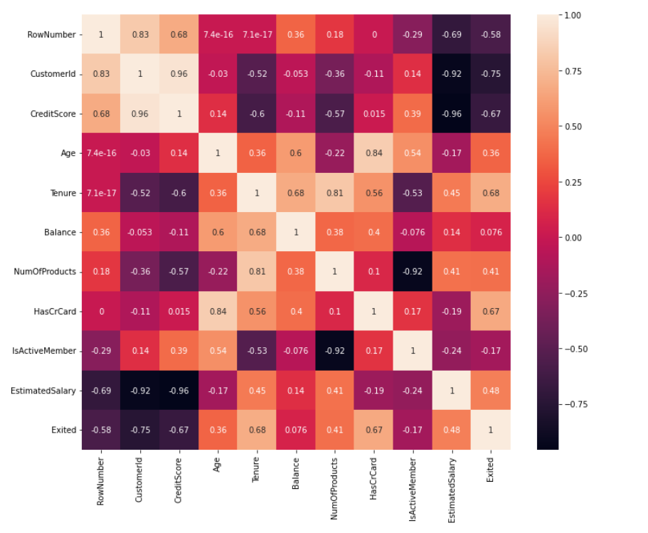

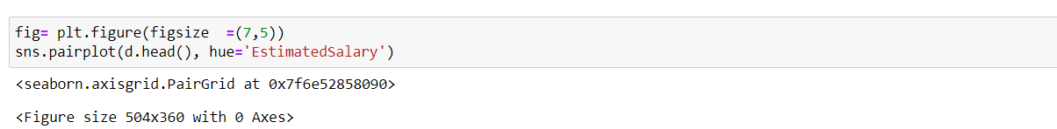

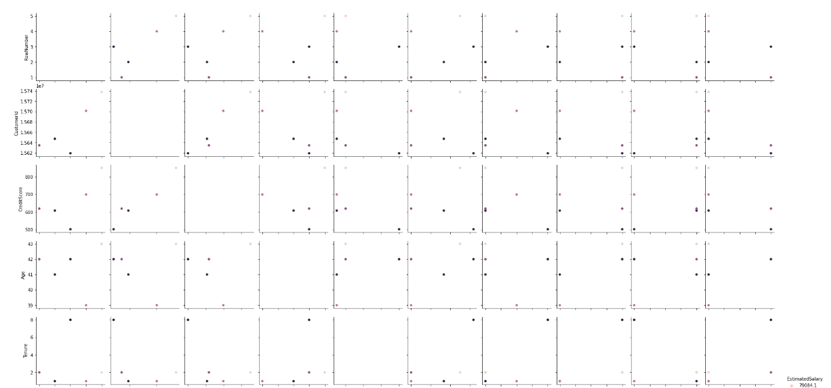

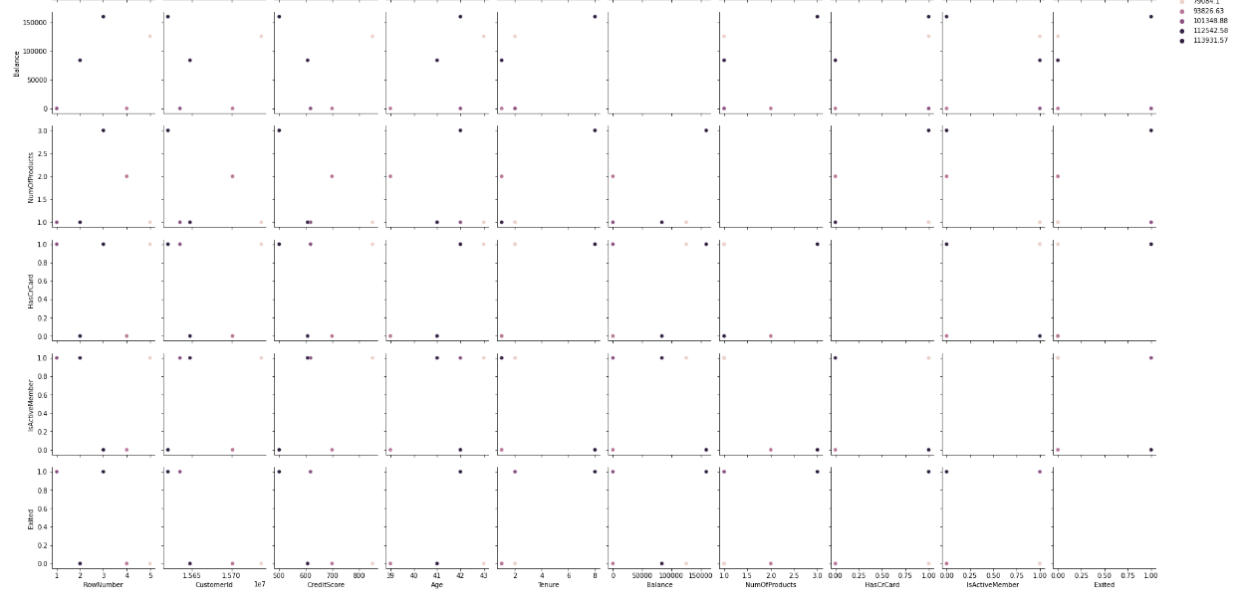

4) Descriptive statistics:

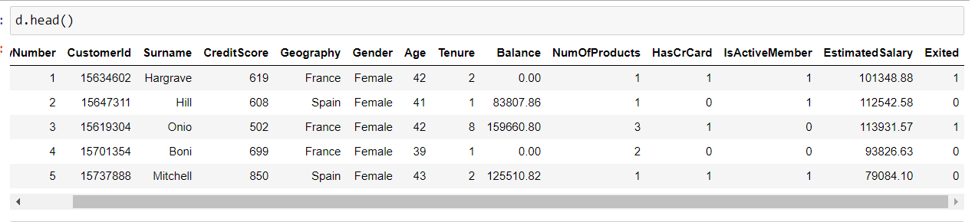

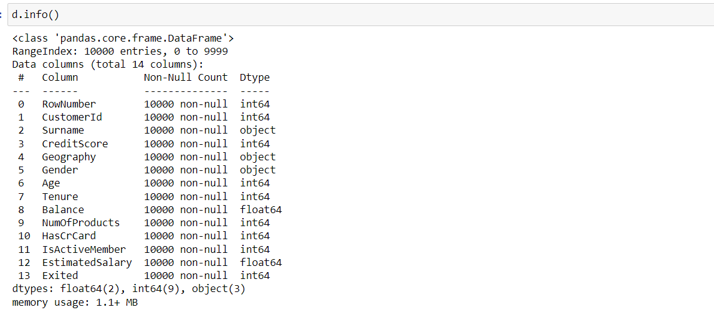

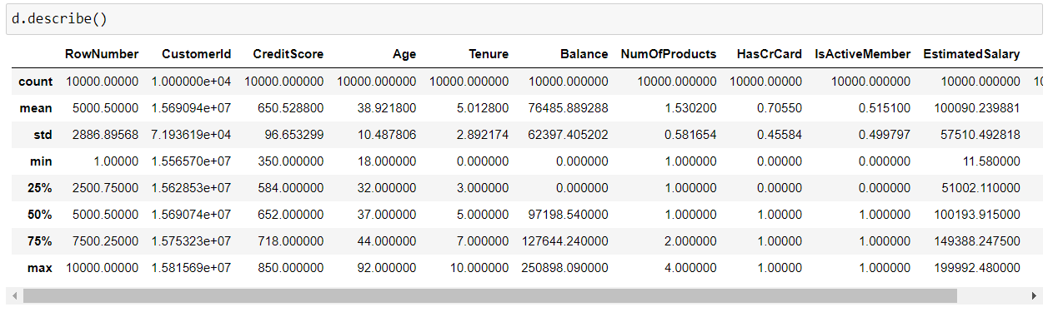

5) Handling of missing values

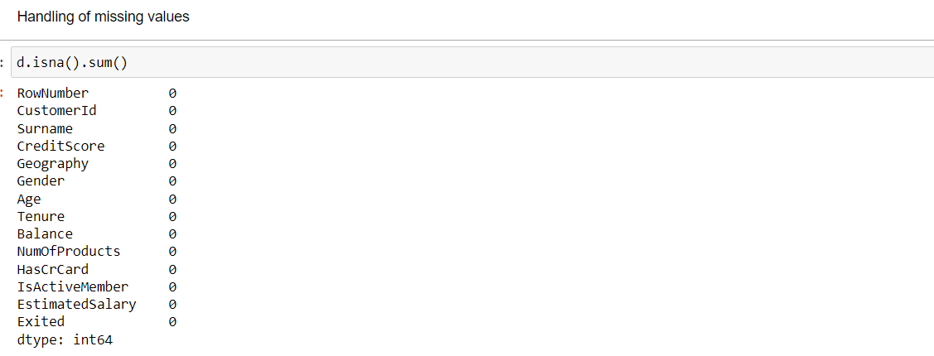

6) Checking for outliers and replacing them

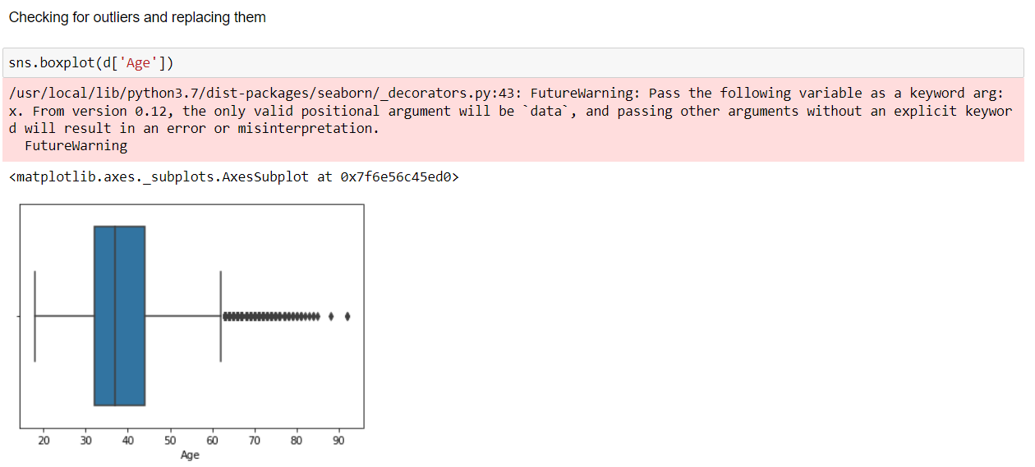

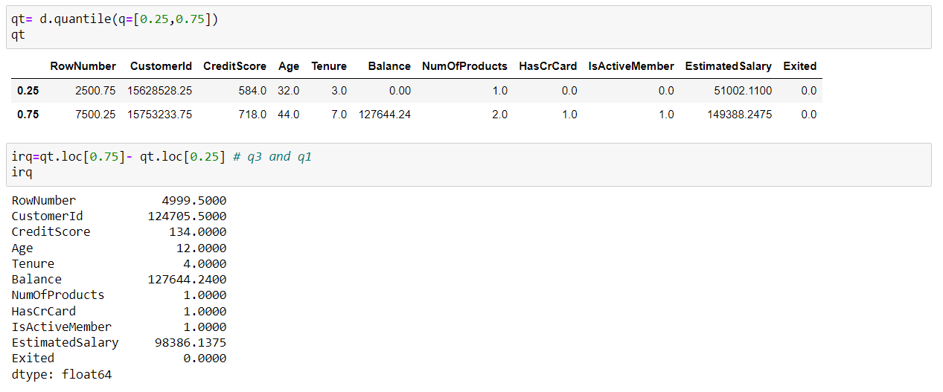

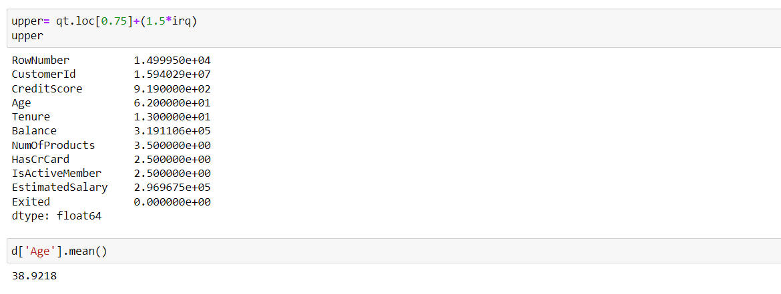

7) Categorical data and Encoding:

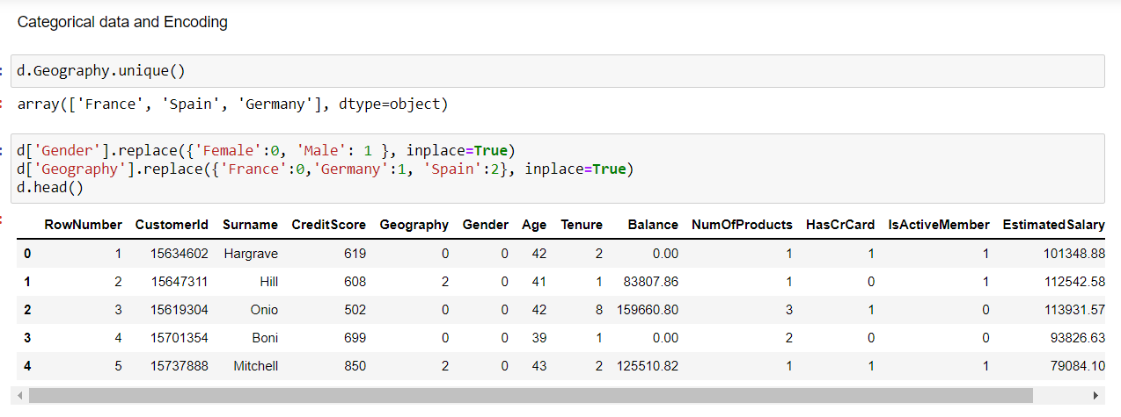

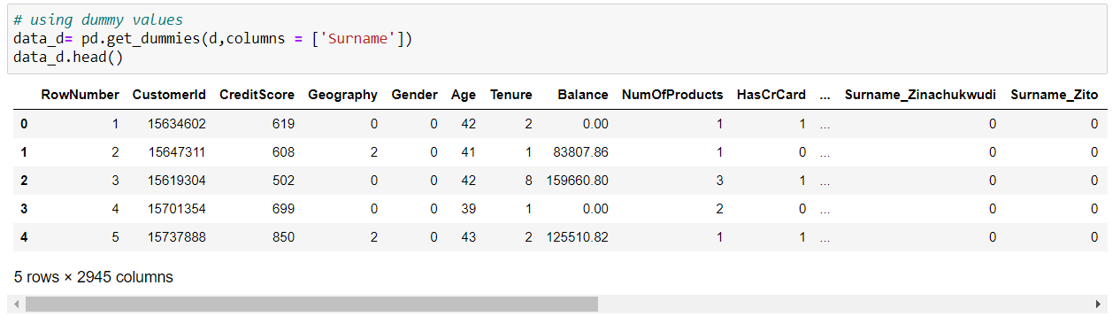

8) Splitting the data into dependent and independent variables

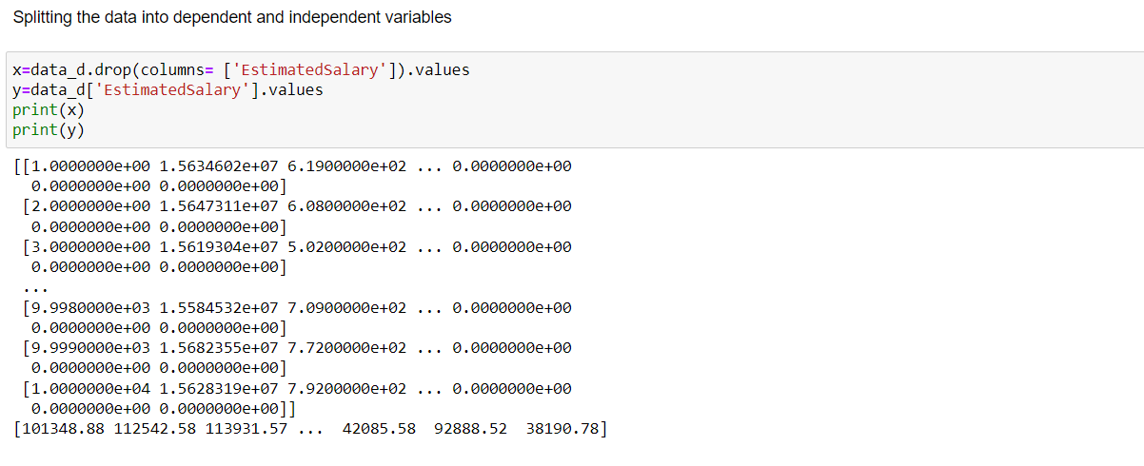

9) Scaling the independent variables

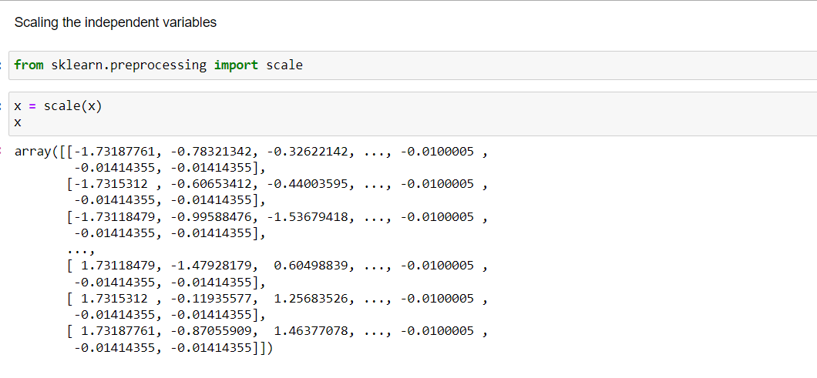

10) Splitting the data into training and testing

